**ASSIGNMENT – 24.2**

**Problem statement:**

* Fetch date and temperature from temperature_data where zip code is greater than 300000 and less than 399999.
* Calculate maximum temperature corresponding to every year from temperature_data table.
* Calculate maximum temperature from temperature_data table corresponding to those years which have at least 2 entries in the table.
* Create a view on the top of last query, name it temperature_data_vw.
* Export contents from temperature_data_vw to a file in local file system, such that each file is '|' delimited.

**Input Data set:**

<https://drive.google.com/file/d/0Bxr27gVaXO5sa0JBamZXdkpYUFk/view?usp=sharing>

**Solution:**

* **Fetch date and temperature from temperature_data where zip code is greater than 300000 and less than 399999.**

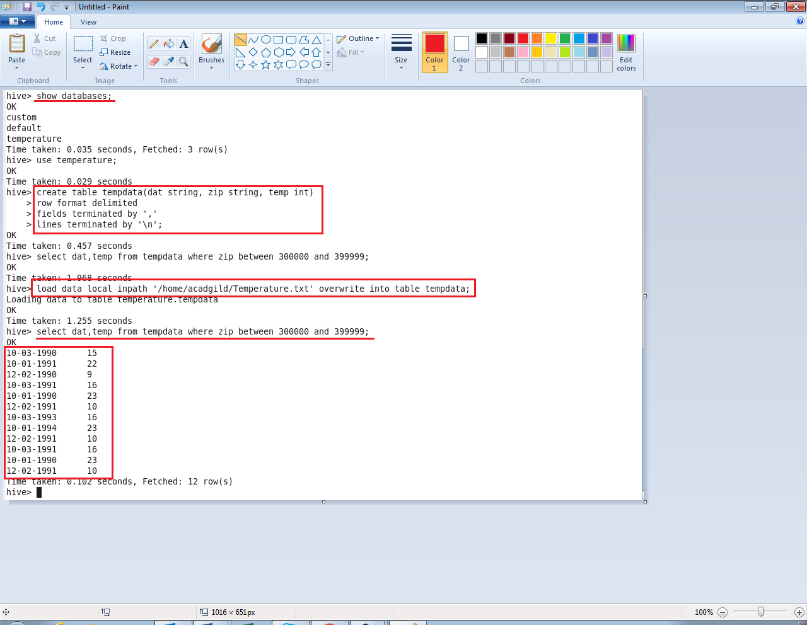

* **Calculate maximum temperature corresponding to every year from temperature_data table.**

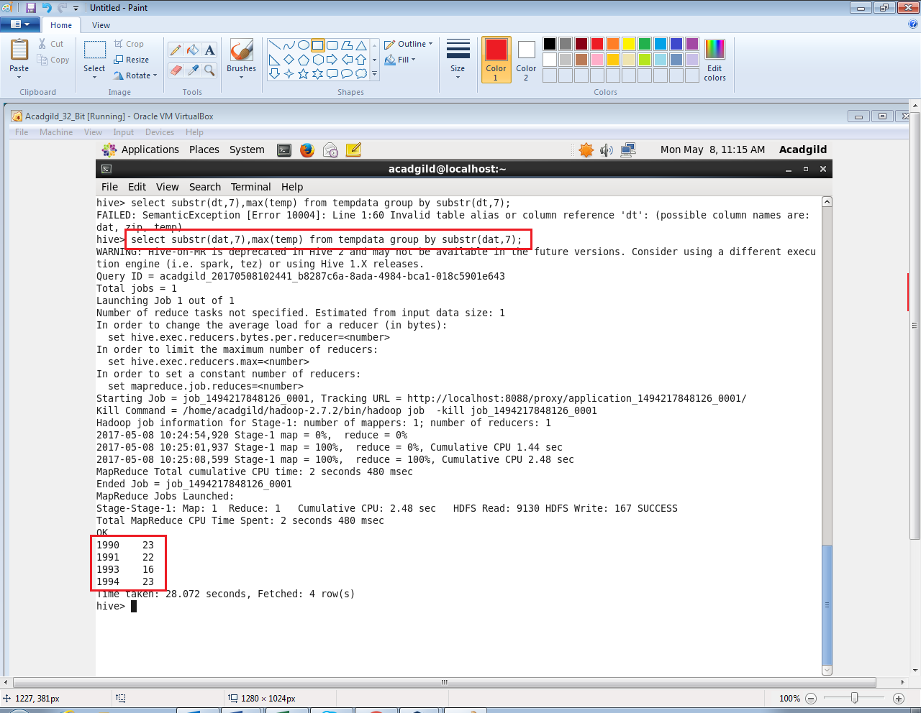

* **Calculate maximum temperature from temperature_data table corresponding to those years which have at least 2 entries in the table.**

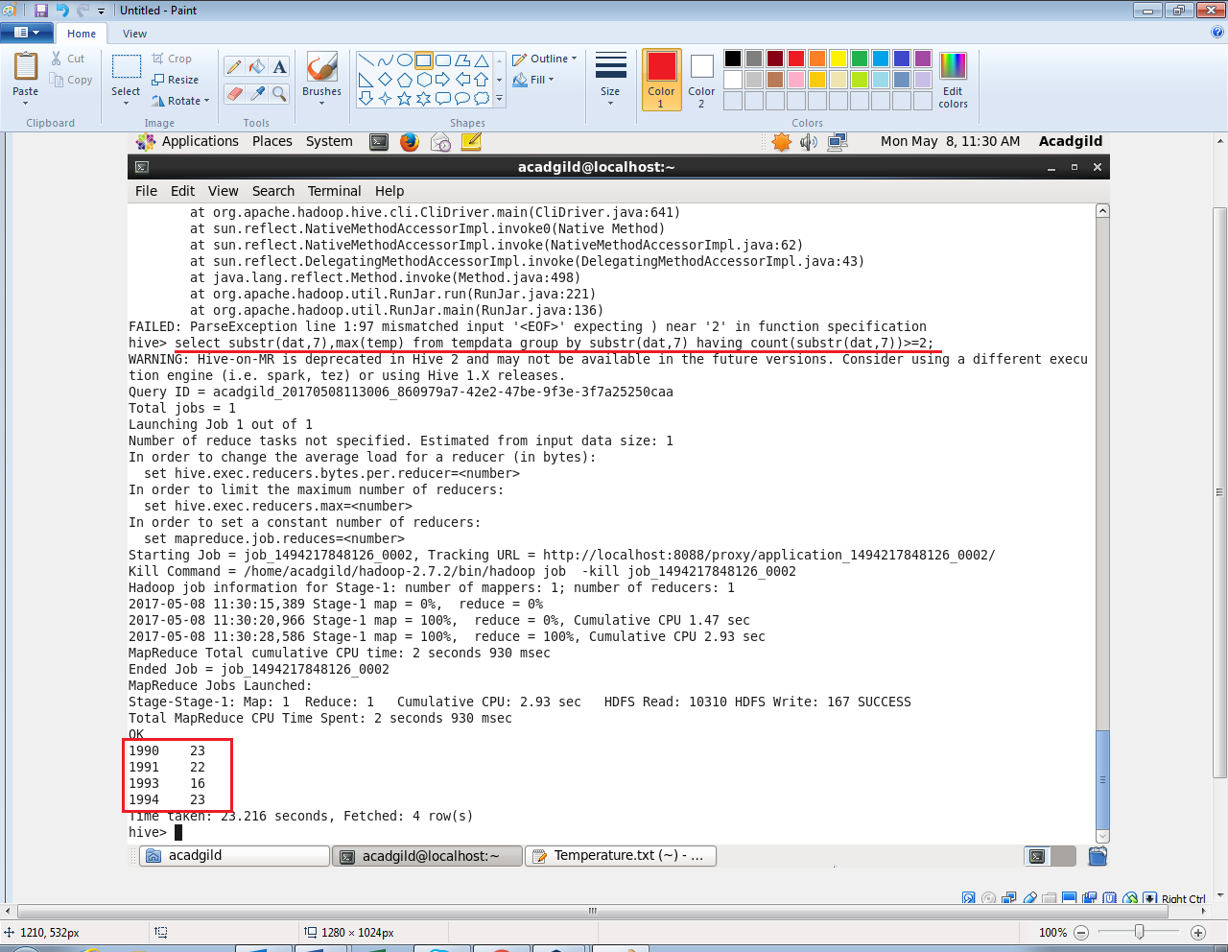

* **Create a view on the top of last query, name it temperature_data_vw.**

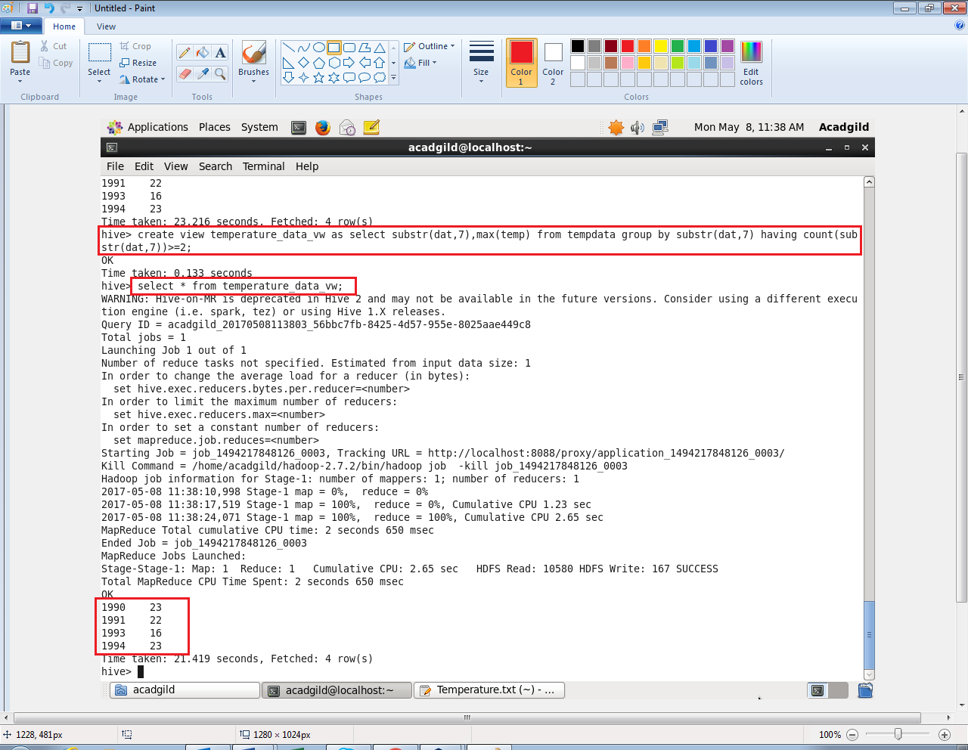

* **Export contents from temperature_data_vw to a file in local file system, such that each file is '|' delimited.**

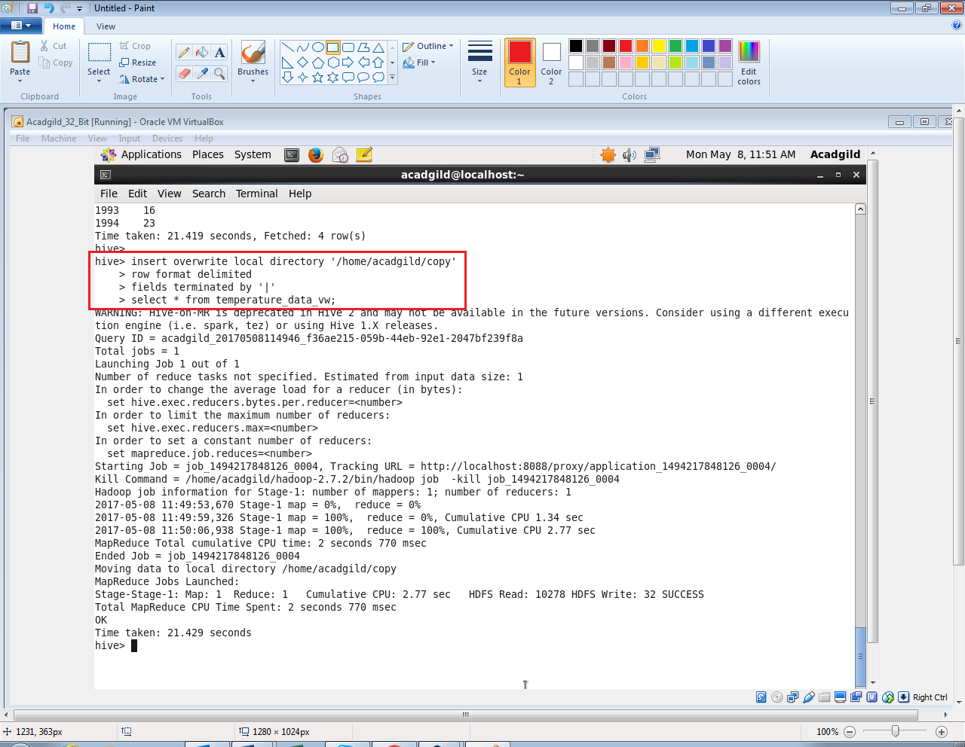

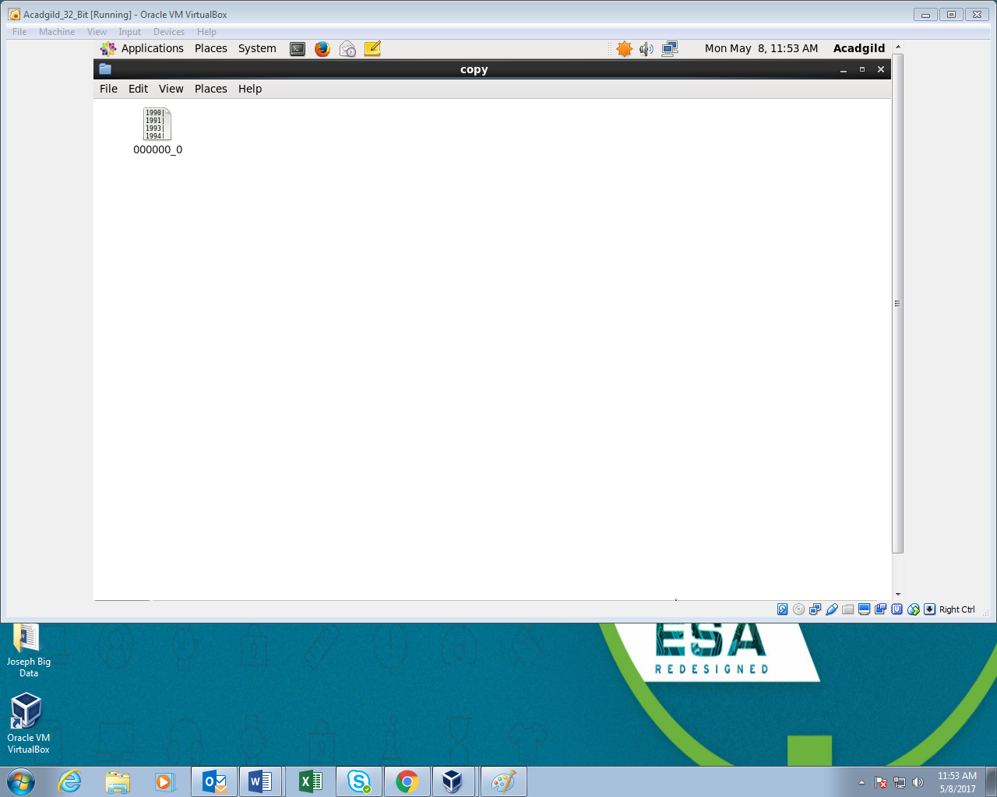

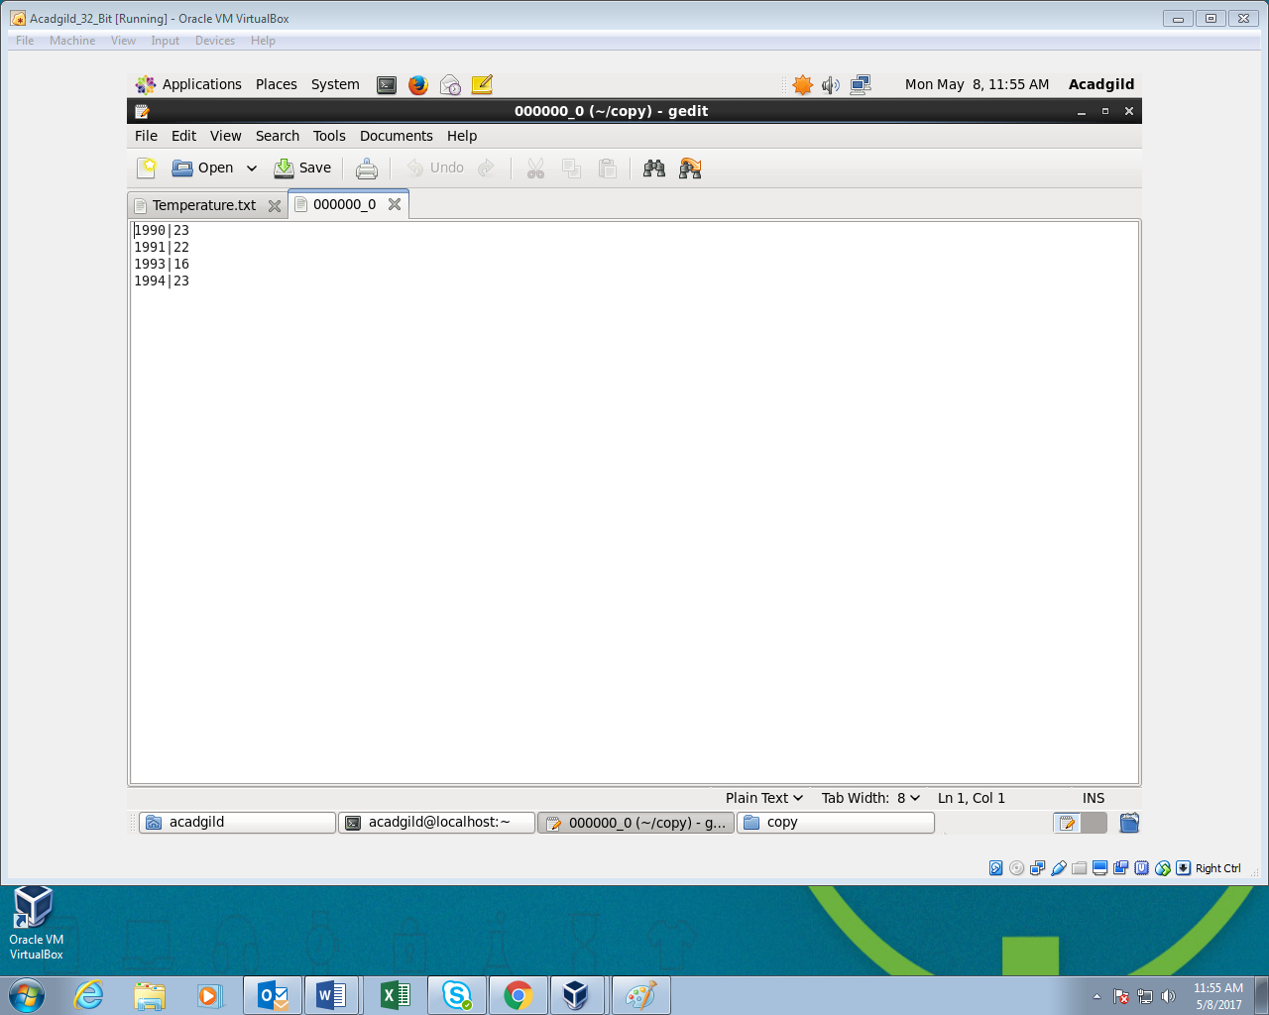

The copy folder is created in given path and the fields are delimited by ‘|’ in the file.